**PROJECT: MERCADO LIBRE**

The project is intended to create a dashboard that collects and summarize the data from a web tool, the idea behind is to provide a tool where the team leaders can supervise their teams and do a fast decision in case an agent is taking too long to finish a chat.

The advantages of the project are going to be:

* Filter the list of agents by different conditions, like date, LOB’s, status, etc.
* Available to view historical chat data.
* Sort from different fields.
* Have indicators for each LOB which are going to be summarized.

The project will be made by:

* Automation: the process in background that will collect the data.
* Dashboard: a web page where the use will supervise their teams.
* A maintenance web page, to do maintenance to agents, TL’s, LOB’s

Also, the chats are going to be seen from 2 options:

* By clicking from the dashboard an agent
* By entering a specific case number

**AUTOMATION**

The dashboard will be created from the information collected in this page by a process that is going to be running background on the server by a process we will name as automation:

Right now we don’t have an idea how long it is going to take the automation to collect all of the information, this automation will run (as an average) every 2 minutes in the server to collect the information.

In case there are LOB’s with information very static, we can split the automation in 2 processes, one for the LOB’s that have static data, and another for the rest.

In case the automation process takes a lot of time we can also split in different processes running in parallel for specific LOB’s, and for this we will need different credentials, nevertheless, this is going to be evaluated until we know how long the process is going to take.

What was requested but it is not possible to provide is the number of chats expired or abandon, because there isn’t any place where the automation can retrieve that information, once the agent stops the chat we cannot know if it was successful, abandon, or the chat expired.

**DASHBOARD WEB PAGE**

The dashboard will be presented in a web environment, the reason for that is:

* it will be centralized.
* It will not need to be install in different machines.
* Any change will apply to all users.

Once the user types the url it will show the following information:

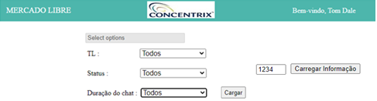

When a user connects to the web tool it will be recognized and will present who is connected at the top right corner of the screen.

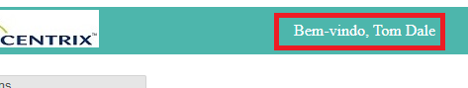

If it is not set his credentials in the database it will show a pop up message “You are not authorized, contact the administrator”.

The first filers are:

|  |  |
| --- | --- |
| Select the list of LOB’s.  Select a TL or all from the dropdown control.  Select a status or all from the dropdown control.  Select the starting duration of the chats. |  |

|  |  |
| --- | --- |
| When selecting the LOB’s the user can select all of the LOB’s or a list by clicking the selection: |  |

|  |  |
| --- | --- |
| The user can filter by different selections, for example, in this case we have selected 2 LOB’s, for TL Ariane Simao, for the agents with status in “Descanso” (Break), for the chats with more than 2 munutes, for July 15. |  |

|  |  |
| --- | --- |
| Once selected the conditions the user will click the button to load the data, if the user selects one or more LOB’s it will show the following grid: |  |

This grid will present, for the specific date selected, a summary of indicators, like the number of agents assigned to each LOB, the number of agents online, offline, in break (Descanso), how many have the status arrested, sick, on vacation, and how many chats have been closed for that specific date.

Remember, if the user doesn’t select any LOB, the previous grid will not be seen.

Below the previous grid it will show another grid, with the lists of agents like the following:



The information is the following

* Agent name (nome).
* TL, an abbreviation of the Team Leader.
* Current status of the agent.
* Login time.
* Last update time for the current status.
* Duration of the current first chat.
* Duration of the second current chat.
* Duration o the third current chat.

The user is going to be able to sort the data by clicking at the top, in the title, the columns that are links, like: Name (nome), TL, Status, Chats (number of chats closed)

If the user can click the button Actions (Acoes) on each row if he wants to know, the detail of the tracker for the date selected:

From this web page, the user is going to be able to click on a case number and it will show below the information of the chat, this was requested for daily chats only.

**DATA MAINTENANCE**

We have to provide maintenance to the following information:

* Assign agents to a TL, and LOB.
* Create new TL, or assign them to a specific LOB.

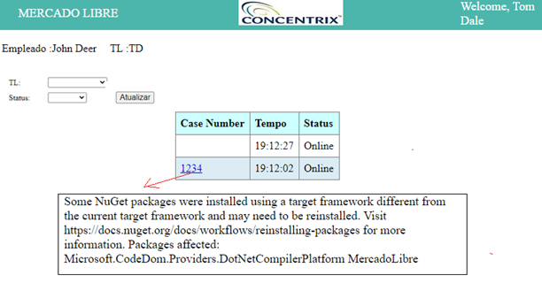

The agents are going to be added automatically if they are taking chats, but at that moment they are not going to have a TL assigned to them, so they need to be related to them.

The TL’s are going to be assign to a LOB, the following page is going to use for this:

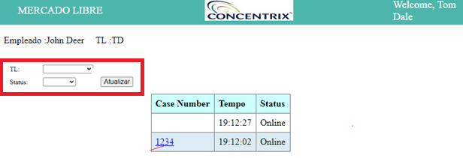

Also, the dashboard is going to validate that the TL exists and has a valid S.O. credential, like [CONCENTRIX@erik.marroquin](mailto:CONCENTRIX@erik.marroquin) if the TL doesn’t have a reference in the database the dashboard is not going to allow him to access the information.

**VIEW CHATS BY CASE NUMBER**

The user can also check the chats by typing the case number, it will be used the following page:

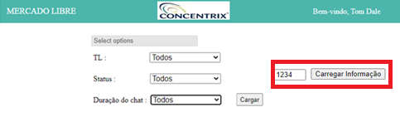

It will pop up a new web page that will show the information of the chat.

